In-Lab assignment: Data

Preprocessing and visualization

In this assignment, we shall explore a sample dataset using pandas and matplotlib.

**About this Dataset:** [*Netflix*](https://en.wikipedia.org/wiki/Netflix) *is one of the most popular media and video streaming platforms. They have over 8000 movies and tv shows available on their platform, and as of mid-2021, they have over 200M Subscribers globally. This tabular dataset consists of listings of all the movies and tv shows available on Netflix, along with details such as - cast, directors, ratings, release year, duration, etc.*

***Information about database:***

* **Show_id**: Unique ID for every Movie / Tv Show
* **Type**: Identifier - A Movie or TV Show
* **Title**: Title of the Movie / Tv Show
* **Director**: Director of the Movie
* **Cast**: Actors involved in the movie/show
* **Country**: Country where the movie/show was produced
* **Date_added**: Date it was added on Netflix
* **Release_year**: Actual Release year of the movie/show
* **Rating**: TV Rating of the movie/show
* **Duration**: Total Duration - in minutes or number of seasons
* **Listed_in**: Genre
* **Description**: The summary description

Q1. Using a pie chart, find the percentage share of TV shows and Movies.

Instructions:- Upload pie chart (correctly labeled and the respective

percentage values)

Ans:

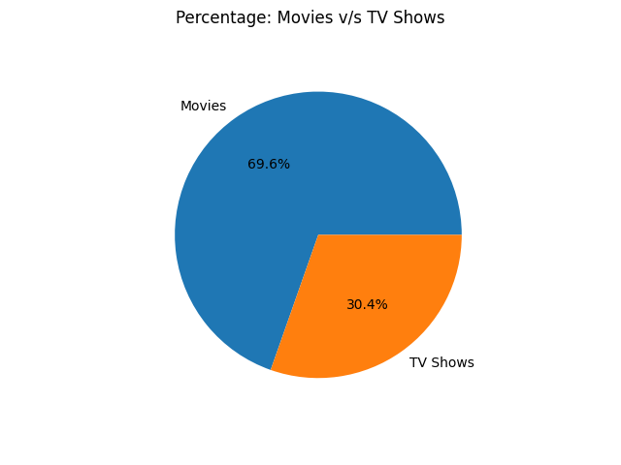

Q2.Plot a bar chart showing top 5 regions having the highest number of shows(both TV

Shows and Movies)

Instructions:

x-axis: Regions.

y-axis: Total number of shows.

The bar chart should be sorted in ascending order and should contain only top

5 countries with proper labels. Upload your bar chart.

Ans:

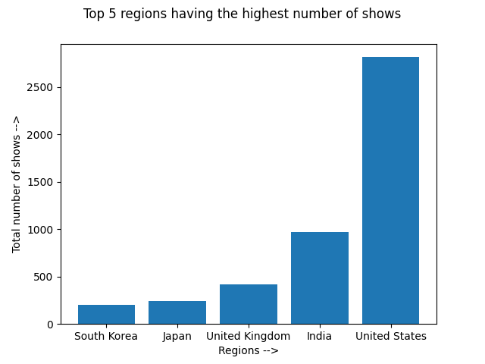

Q3. Using a heatmap answer the following questions.

Do for both Movies and TV shows separately:

a. After which year do the shows start appearing on Netflix?

b. In 2021, in which month were most shows added?

Note:- Make two separate heatmaps, one for TV shows and one for Movies and

answer the two questions in the context of both the types

Heatmap should have the y-axis as months and the x-axis as years.

Ans:

a) Movies started appearing from 2008, however, a significant increase in the number of movies started from 2016 (after 2015, about 450% increase).

b) In 2021, most movies were added in the 7th month, that is the month of July.

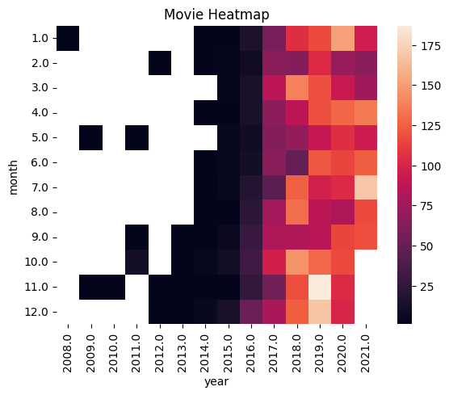

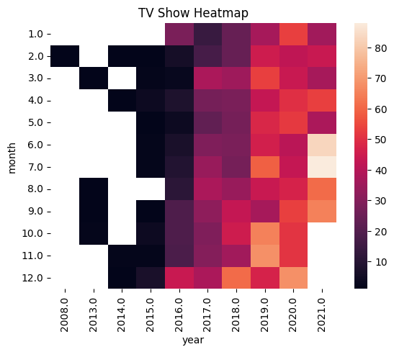

Q4. Using a line graph, tell which year and which

month has the highest:

a. TV Shows

b. Movies

c. Total shows (TV shows + Movies)

Note:- 2 separate plots 1 for year-wise distribution and one for monthly

distribution (three different data in the same plot:- Movies, TV shows and Total; each

with a different color)

Q5. Does Netflix have more focus on TV Shows than movies in recent years? Backup your answer using some plot/graph and upload it.